**Names of Group Members:**

Heinrich Conradie, 27469352

Hugo van Schalkwyk, 31586872

**Description of Topic:** Textbook Management System for a High school

**Programming Language:** C#

**Database Management System:** Microsoft SQL Management Studio

**Physical Data Model**

Insert image

**Physical Process Model**

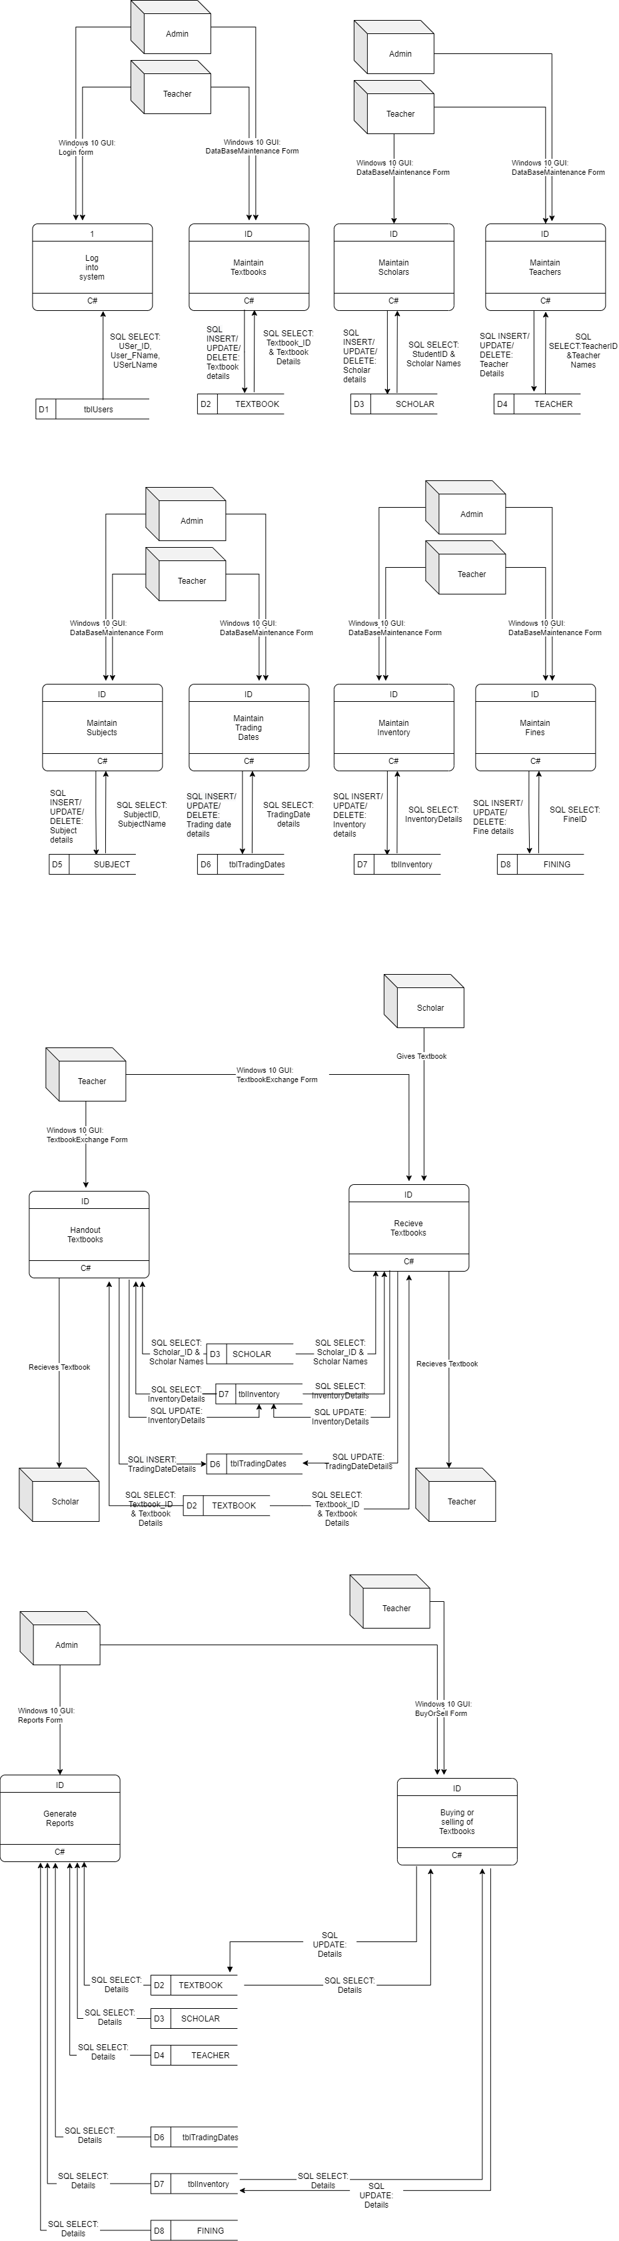



**Database Schema**

Insert image

**All SQL Used**

**Maintaining a Child entity of the data model**

Insert image

**Reuse of code**

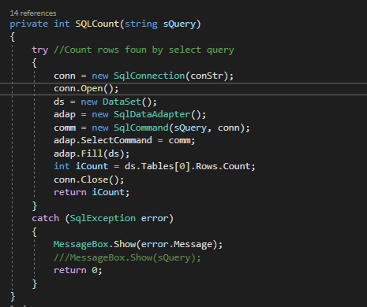

**Summary Reports**

Insert image

**User Manual**

Getting Started:

System requirements:

* Windows 10
* 1.8 GHz or faster 64-bit processor, Quad-core
* 4 GB of RAM
* 20GB available storage space

**Detail Dairy**

Heinrich Conradie:

|  |  |  |
| --- | --- | --- |
| **Date** | **Time Spent** | **Brief Description of Work** |
| 30 Sept. | 0:10 | Created Base Form |
| 6 Oct. | 1:05 | Started work on report form |
| 7 Oct. | 3:52 | Continued Report form and started BuySell form |
| 8 Oct. | 1:20 | Completed SQL statements for Reports |
| 9 Oct. | 2:29 | Adapted SQL statements for BuySell form and started doc. |
| 10 Oct. | #:## | Testing, bug fixing and documentation |
| TOTAL | #:## |  |